Story

Date | 26 July 2026
Team ID | Lisha Chaudhary
Project Name | Food Ordering behaviour
Maximum Marks | 5 Marks

Activity 1: Story Design:

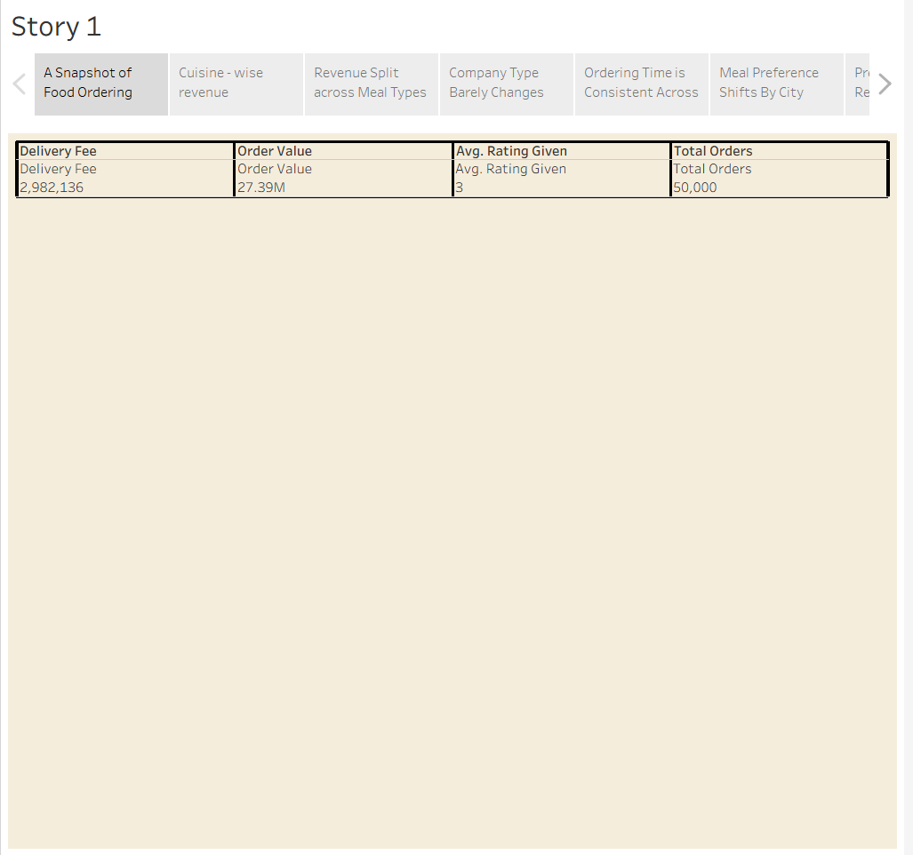

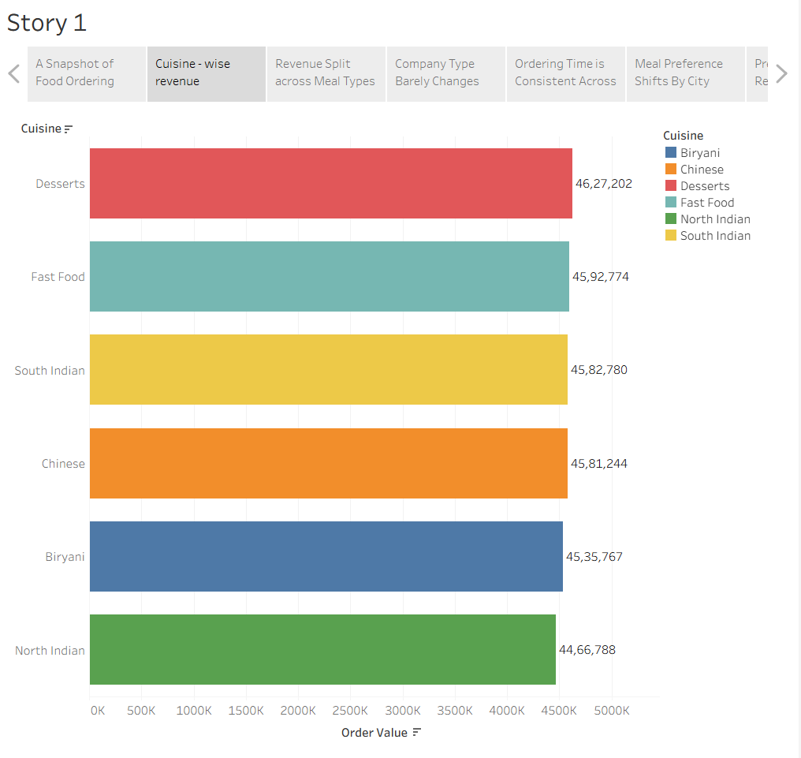
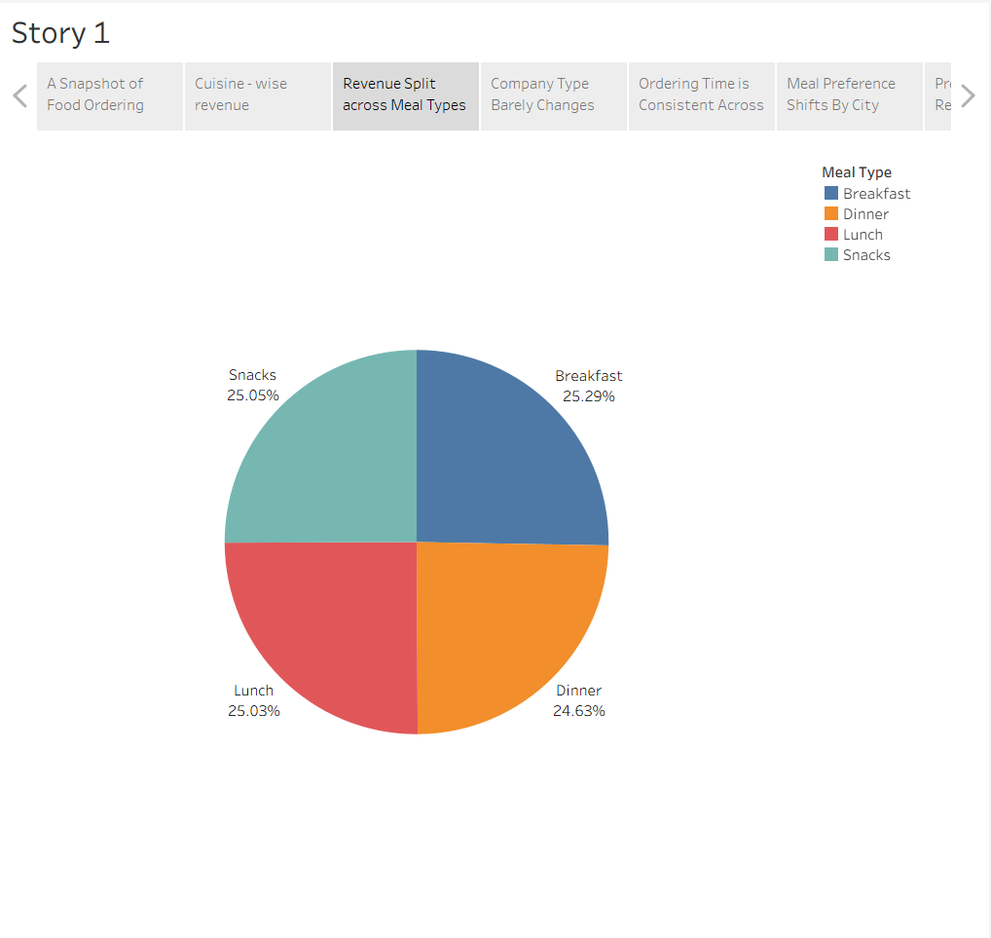
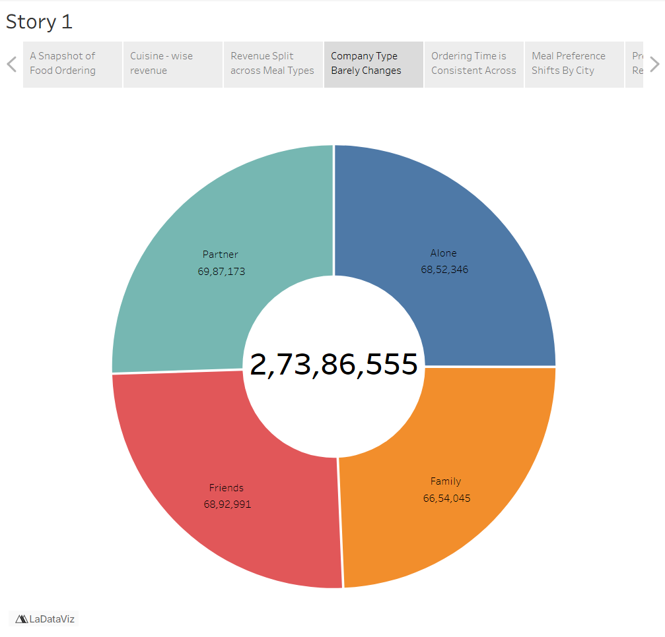
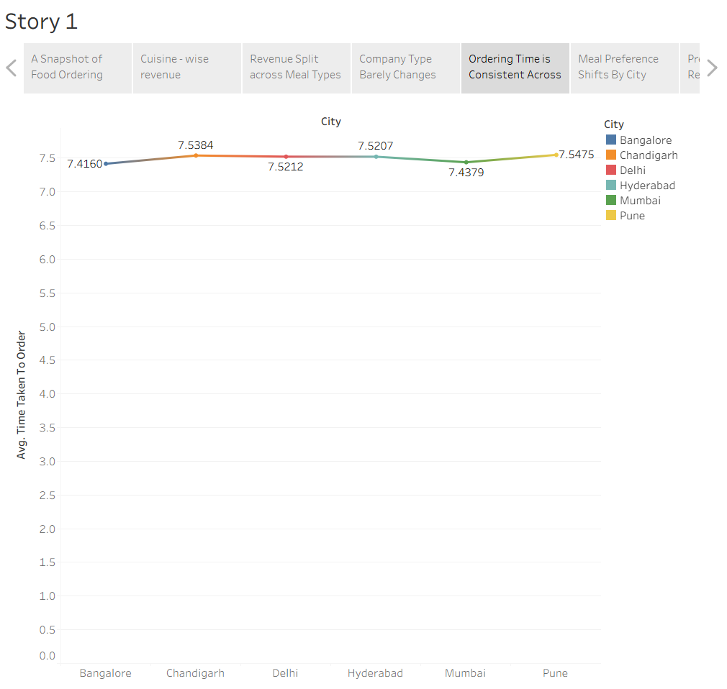
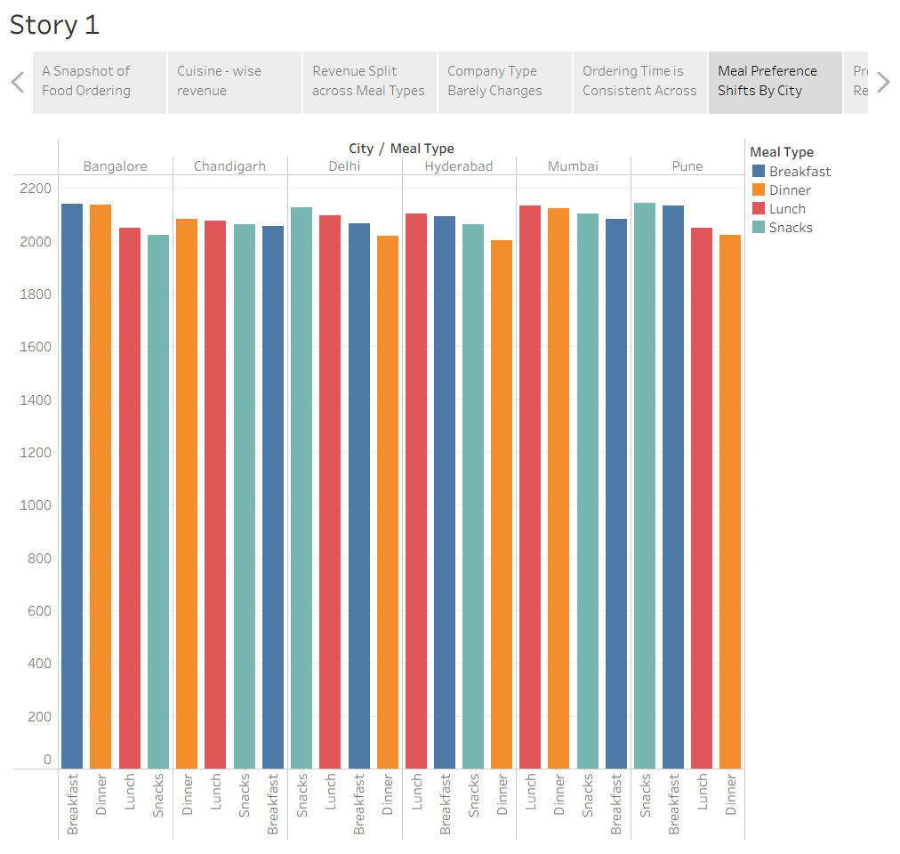
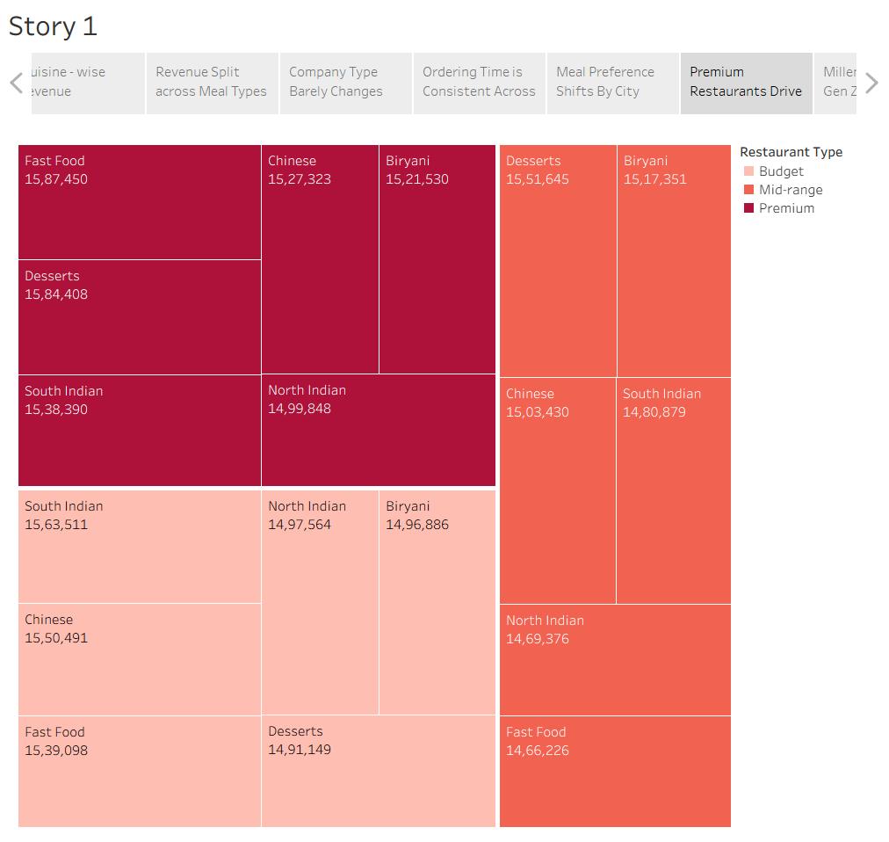
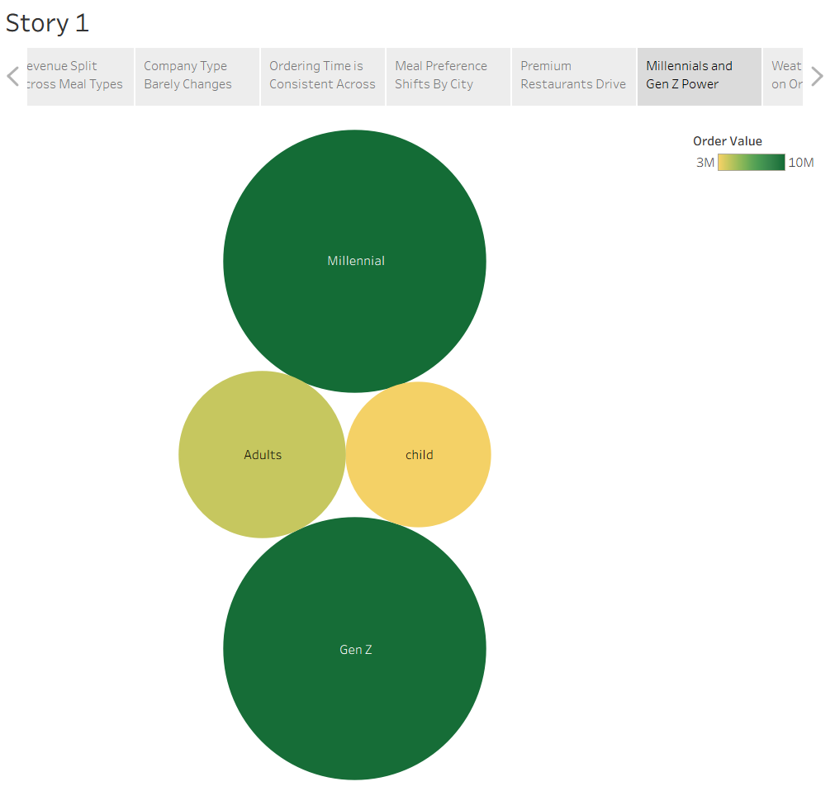
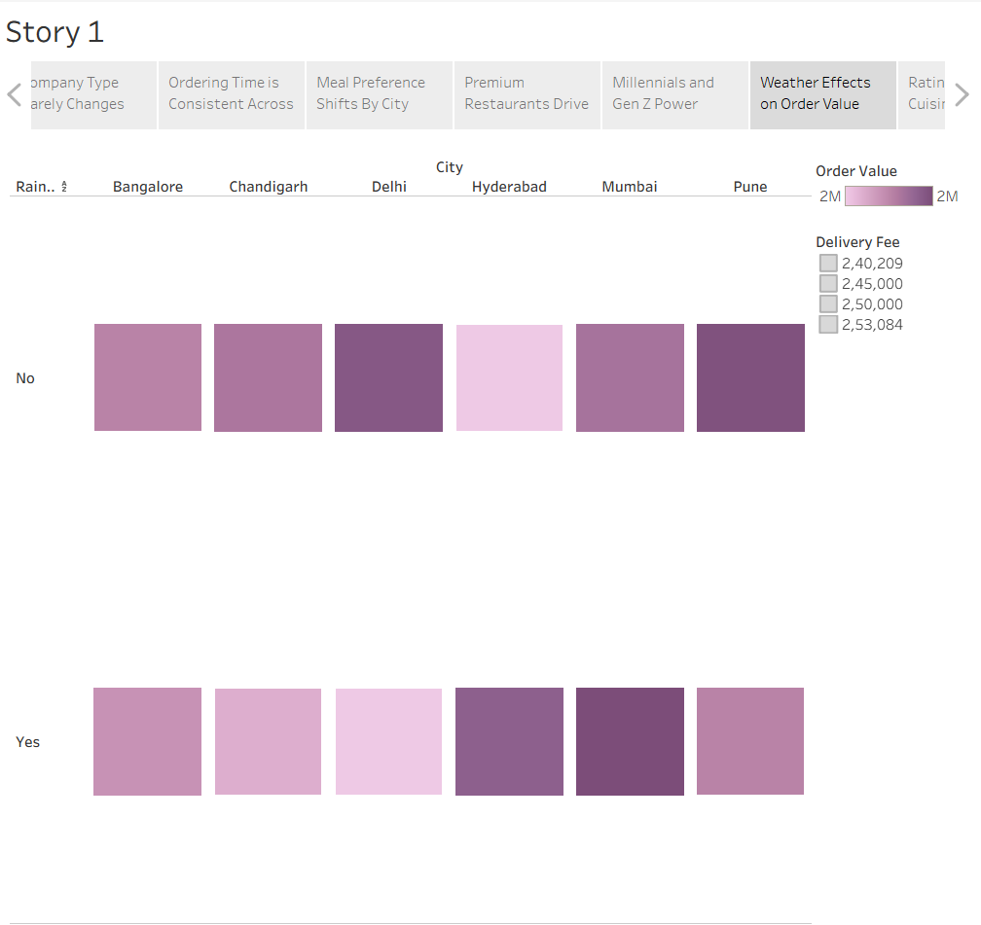
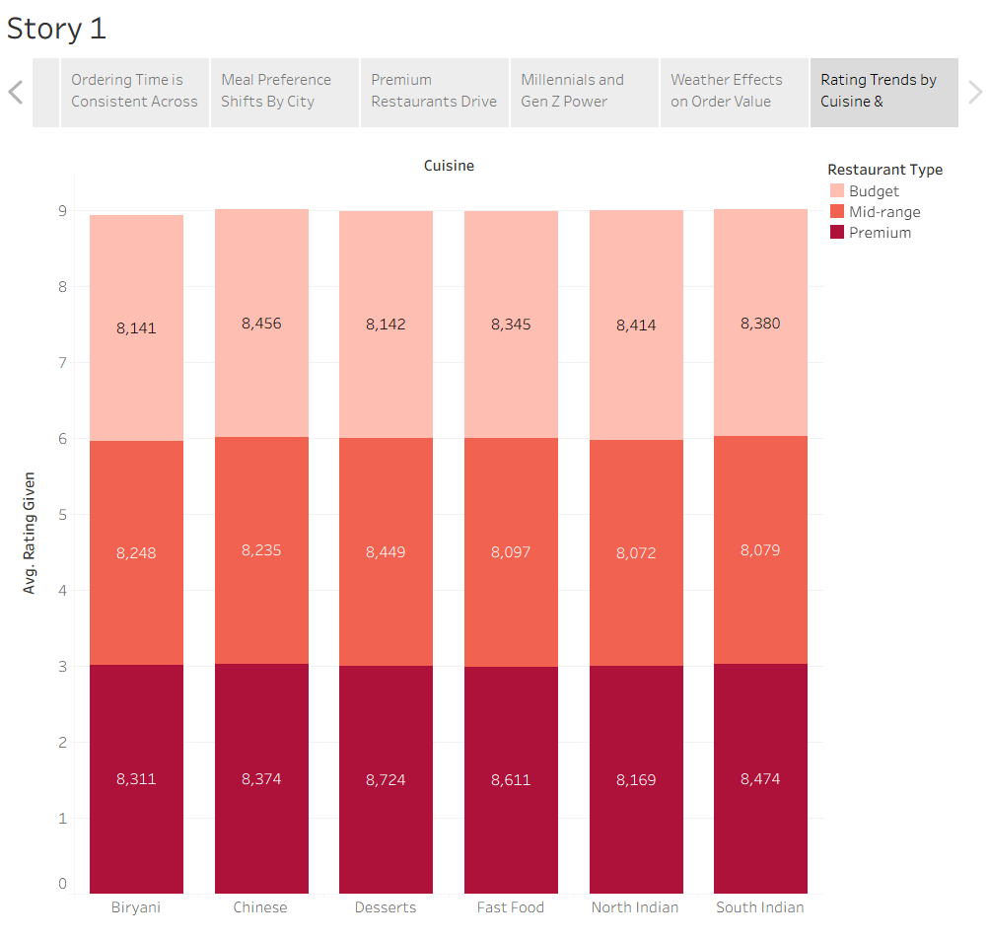

Tableau Story Narrative & Observations
By leveraging the sequential story point structure in Tableau, the Food Ordering Behaviour analytical presentation guides business stakeholders through a logical progression of customer, revenue, and operational metrics, turning raw order data into a cohesive business narrative.

Based on the interactive story points, here are the core observations:
- Cuisine Revenue Is Broad-Based (Point 2): No single cuisine dominates — Desserts lead slightly (₹46.27L), but all cuisines sit within a tight ₹44–46L range, showing diversified demand.
- Meal-Time Demand Is Even (Point 3): Breakfast, Lunch, Snacks, and Dinner each contribute nearly 25% of revenue, indicating steady all-day ordering behavior.
- Company Type Barely Affects Spend (Point 4): Order values stay within a narrow ₹66–70L range whether customers order Alone, with Partner, Family, or Friends.
- City-wise Ordering Time Is Consistent (Point 5): Average time-to-order stays close to 7.5 minutes across all cities, with only minor variation.
- Meal Preferences Vary by City (Point 6): Breakfast peaks in Bangalore, Snacks in Delhi, Lunch in Mumbai — showing localized ordering habits.
- Premium Restaurants Lead Revenue (Point 7): Premium-tier restaurants outperform Mid-range and Budget across most cuisines, led by Fast Food and Desserts.
- Millennials & Gen Z Drive Growth (Point 8): These age groups generate significantly higher revenue than Adults and Children.
- Weather Has Minimal Impact (Point 9): Order values stay strong on rainy days too, showing demand resilience.
- Ratings Stay Consistently High (Point 10): All cuisines and restaurant types maintain strong ratings (8.0–8.7), with Premium slightly ahead.

Activity 2:
Publish Story on Tableau Public and Paste Public link below-
https://public.tableau.com/views/Story-FoodOrderingBehaviour/Story1?:language=en-US&publish=yes&:sid=&:redirect=auth&:display_count=n&:origin=viz_share_link
Web Deployment URL
https://food-ordering-behaviour-and-consumer.onrender.com/

